**Week 04-02:**

**Name:Snehan.S**

**Roll no:241801272**

1. You are designing a poster which prints out numbers with a unique style applied to each of them. The styling is based on the number of closed paths or holes present in a given number. The number of holes that each of the digits from 0 to 9 have are equal to the number of closed paths in the digit. Their values are: 1, 2, 3, 5, 7 = 0 holes. 0, 4, 6, 9 = 1 hole. 8 = 2 holes. Given a number, you must determine the sum of the number of holes for all of its digits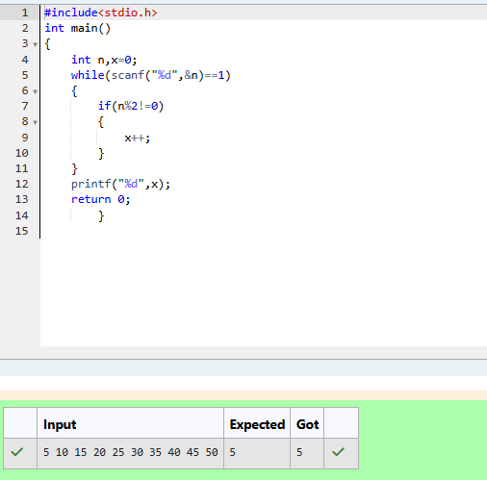

2. Given a number N, return true if and only if it is a confusing number, which satisfies the following condition: We can rotate digits by 180 degrees to form new digits. When 0, 1, 6, 8, 9 are rotated 180 degrees, they become 0, 1, 9, 8, 6 respectively. When 2, 3, 4, 5 and 7 are rotated 180 degrees, they become invalid. A confusing number is a number that when rotated 180 degrees becomes a different number with each digit valid.

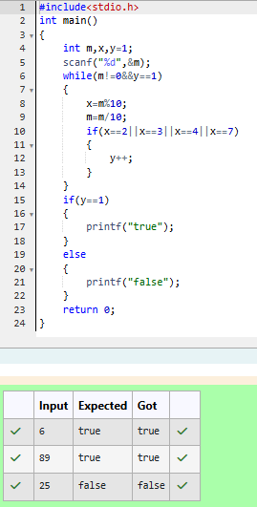

**3.** A nutritionist is labeling all the best power foods in the market. Every food item arranged in a single line, will have a value beginning from 1 and increasing by 1 for each, until all items have a value associated with them. An item's value is the same as the number of macronutrients it has

